**Infringement of Women’s Rights**

Violation of women’s rights have been an issue throughout history. Dehumanization, oppression, and inequality has prevailed throughout the world. In modern times, many first world countries like United States, the United Kingdom, etc. have progressed and women’s status in society has dramatically improved, though there are still gender-related problems that occur. In third world countries, treatment towards females and their lifestyles are horrid and have not changed since the past. While we are in the 21rst century, the majority of the world still hold on to beliefs and values from the past and still have a backwards mindset. From the rape culture in Haryana to honor killings in Pakistan, there are an infinite amount of struggles women face every day of their lives, some even a matter of life and death.

**Forced/ Child Marriages**

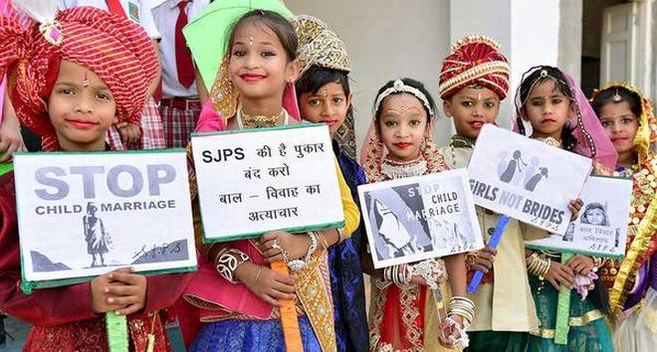

Forced and child marriages is still a very common occurrence in many third-world countries. Millions of girls are being wedded off without their consent in India, Bangladesh, Pakistan, Niger, Brazil, Central African Republic, and countless other regions. Girls from the age of 5 to 20 are given away by their parents to or are promised to, in most cases, a much older man. For the most part, these cases occur due to: the family’s financial situation, the idea that “Girls should be married early” or “Parents know best” is embedded into their culture or tradition, girls being valued less than boys, and/or to ensure safety against harassment and sexual assault. There are 12 million underage girls that are married under the age of 18 every year, and being married at such a young age hinders a girl’s ability to gain an education or even be an individual. Many have been able escape, but the majority have to deal with this for the rest of their lives. More likely than not, their partner is very abusive and his family treat the girl like a slave. Time and time again,women have committed suicide due to their abusive relationship and not being able to escape it.

Links: <https://www.girlsnotbrides.org/about-child-marriage/>

https://www.globalcitizen.org/en/content/5-countries-with-highest-child-marriage/

Related: *Bride Kidnappings:* <https://www.news.com.au/lifestyle/real-life/news-life/its-hard-to-believe-that-bride-kidnapping-exists-in-2017/news-story/9e7a445078231d94da67be33e3bb9157>

*Bride Markets:* [*https://www.news.com.au/lifestyle/real-life/news-life/inside-bulgarias-traditional-bridal-market-where-teen-girls-are-sold-for-hundreds-of-dollars/news-story/f1e6eb4460b5bf1806bff9602ad527a0*](https://www.news.com.au/lifestyle/real-life/news-life/inside-bulgarias-traditional-bridal-market-where-teen-girls-are-sold-for-hundreds-of-dollars/news-story/f1e6eb4460b5bf1806bff9602ad527a0)

How we can help: <https://www.girlsnotbrides.org/how-can-we-end-child-marriage/>

**Safety Issues**

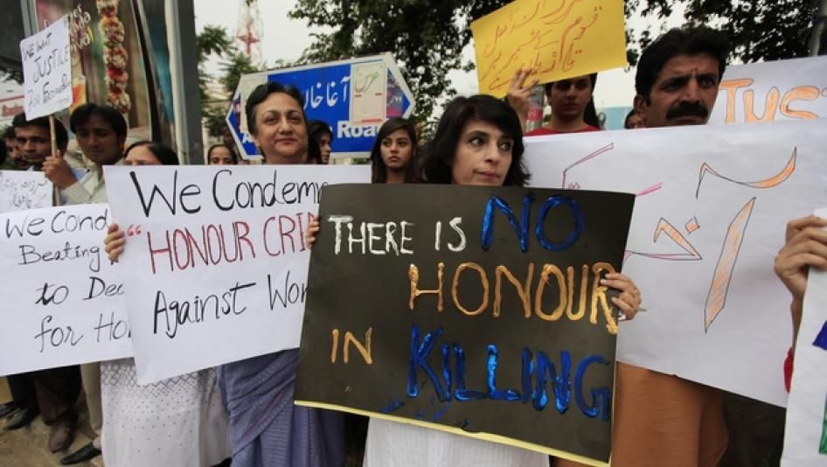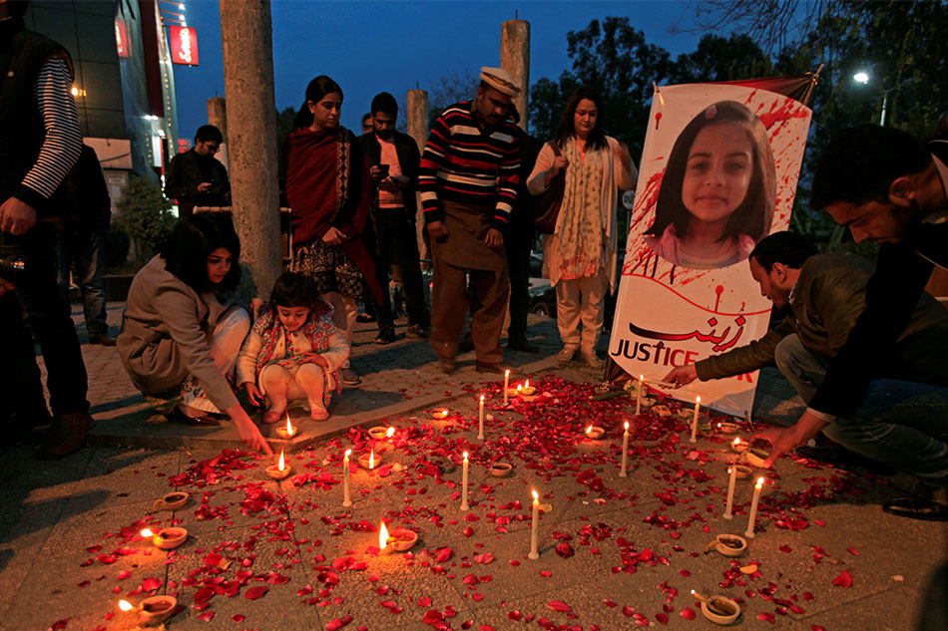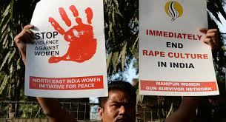

Girls in most third-world countries always have to be aware of their safety. Not only do girls have to face sexual harassment, but in many countries, rape and harassment is not looked upon as an legitimate “issue”. Sexual violence against women is a major problem in South Africa, South Asia, etc. There are multiple cases where in forced marriages, the husband of the girl regularly rapes her to fulfill his sexual desires(e.g. #JusticeforNoura in Sudan). Even unwedded girls live in fear due to the barbaric and evil nature of the men. In South Asian countries, like India, girls cannot walk alone in the streets without continuous ad shameless stares and catcalling from men. Rape culture and the objectification of women is normalized in many parts of India such as Haryana(where rape is deemed as being consensual), and excuses such as “No girl should be outside without a male companion late at night” or “Girls shouldn’t wear such tight and revealing clothes” are repeatedly used to justify this inhumane crime.There have even been a case where a girl as young as 8-months-old has been raped by her 28 year old married cousin. Not only do females have to face sexual assault, but they also have to live in fear of dying. The movement #JusticeforZainab started after the kidnapping, horrendous torture/abuse, rape and murder of a 6 year old girl, Zainab Ansari, whose dead body was found in a dumpster, in Pakistan. This was one of many young female victims that were raped and brutally murdered in Pakistan. Many other murders that occur in Pakistan are known as ‘honor killings’. There have been many times where a girl or woman is killed by a family member if they bring shame to the family(even when it doesn’t matter for males). A well-known honor killing was that of Qandeel Baloch, who was known as the “Pakistani Kim K” for her sexually explicit presence on social media. After being taunted by his friends, her brother killed Kandeel because she brought “dishonor” to the family. This is a common occurrence in Pakistan and other countries with an estimated 5000 cases every year, where families prioritize their reputation and honor over the female members of the family, even so much that they’d kill them for doing anything that hurt their reputation. Women worldwide have to constantly be in fear of getting raped and murdered, and safety is very limited in these countries.

Links: <https://www.cnn.com/2018/08/09/africa/south-african-student-suicide-rape/index.html>

<https://timesofindia.indiatimes.com/india/79-of-women-in-India-faced-public-harassment/articleshow/52369555.cms>

<https://www.youtube.com/watch?v=Pgom8LRF8hQ>

<https://www.newsweek.com/honor-killings-rape-acid-attacks-and-child-abuse-rampant-pakistan-reports-842324>

<https://www.weforum.org/agenda/2016/07/honour-killings-pakistan-qandeel-baloch/>

<https://www.bbc.com/news/blogs-trending-42646151>

<https://www.change.org/p/justice-for-noura-maritalrape-deathsentence-sudan>

How you can help: <https://www.equalitynow.org/most_urgent>

<https://www.marshall.edu/womenstu/stop-abuse/what-you-can-do-to-prevent-violence-against-women/>

**Societal Standards of Living**

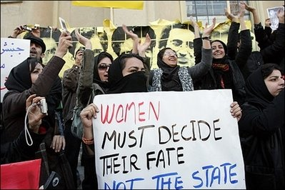

In South Asian, African, and middle eastern countries (like Iran and Saudi Arabia), a woman’s life is dominated by men, from their fathers when they are young to their husbands when they get married. At a young age, they are taught that their life consists of marriage and obeying their husbands, cooking/cleaning, and taking care of her children. They are very oppressed in how they can act(ideal girl is quiet, a good worker, and submissive), what they can say, dress, etc. They aren’t treated as humans but instead as servants and have no voice in any matter. Normally, a girl’s father or husband makes all her decisions for her and in several middle eastern countries, women are denied basic rights--like being able to drive, go out without a male guardian, etc. In certain countries, there are even rules implemented about how a female dresses. In regions where extremists groups are in control(like the Taliban in parts of Pakistan)girls lives are threatened if they decide to do anything against their radical beliefs or something as basic to us as attending school. A major part of the reason why systematic oppression still exists in so many ‘developing’ countries is due to the lack of education girls receive. In many cultures, people don’t believe it is necessary for girls to have an education, because their primary job is apparently to serve their husbands. For cultural and many other reasons, 65 millions of girls globally aren’t in school.

Links:

<https://www.nationalgeographic.com/magazine/2016/03/3-questions-malala-yousafzai/>

<https://www.dw.com/en/womens-rights-in-the-islamic-world/a-40714427>

What we can do to help: <https://www.malala.org/>

<https://www.globalfundforwomen.org/>

**Health and Diseases**

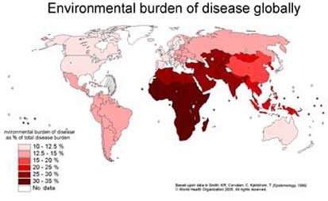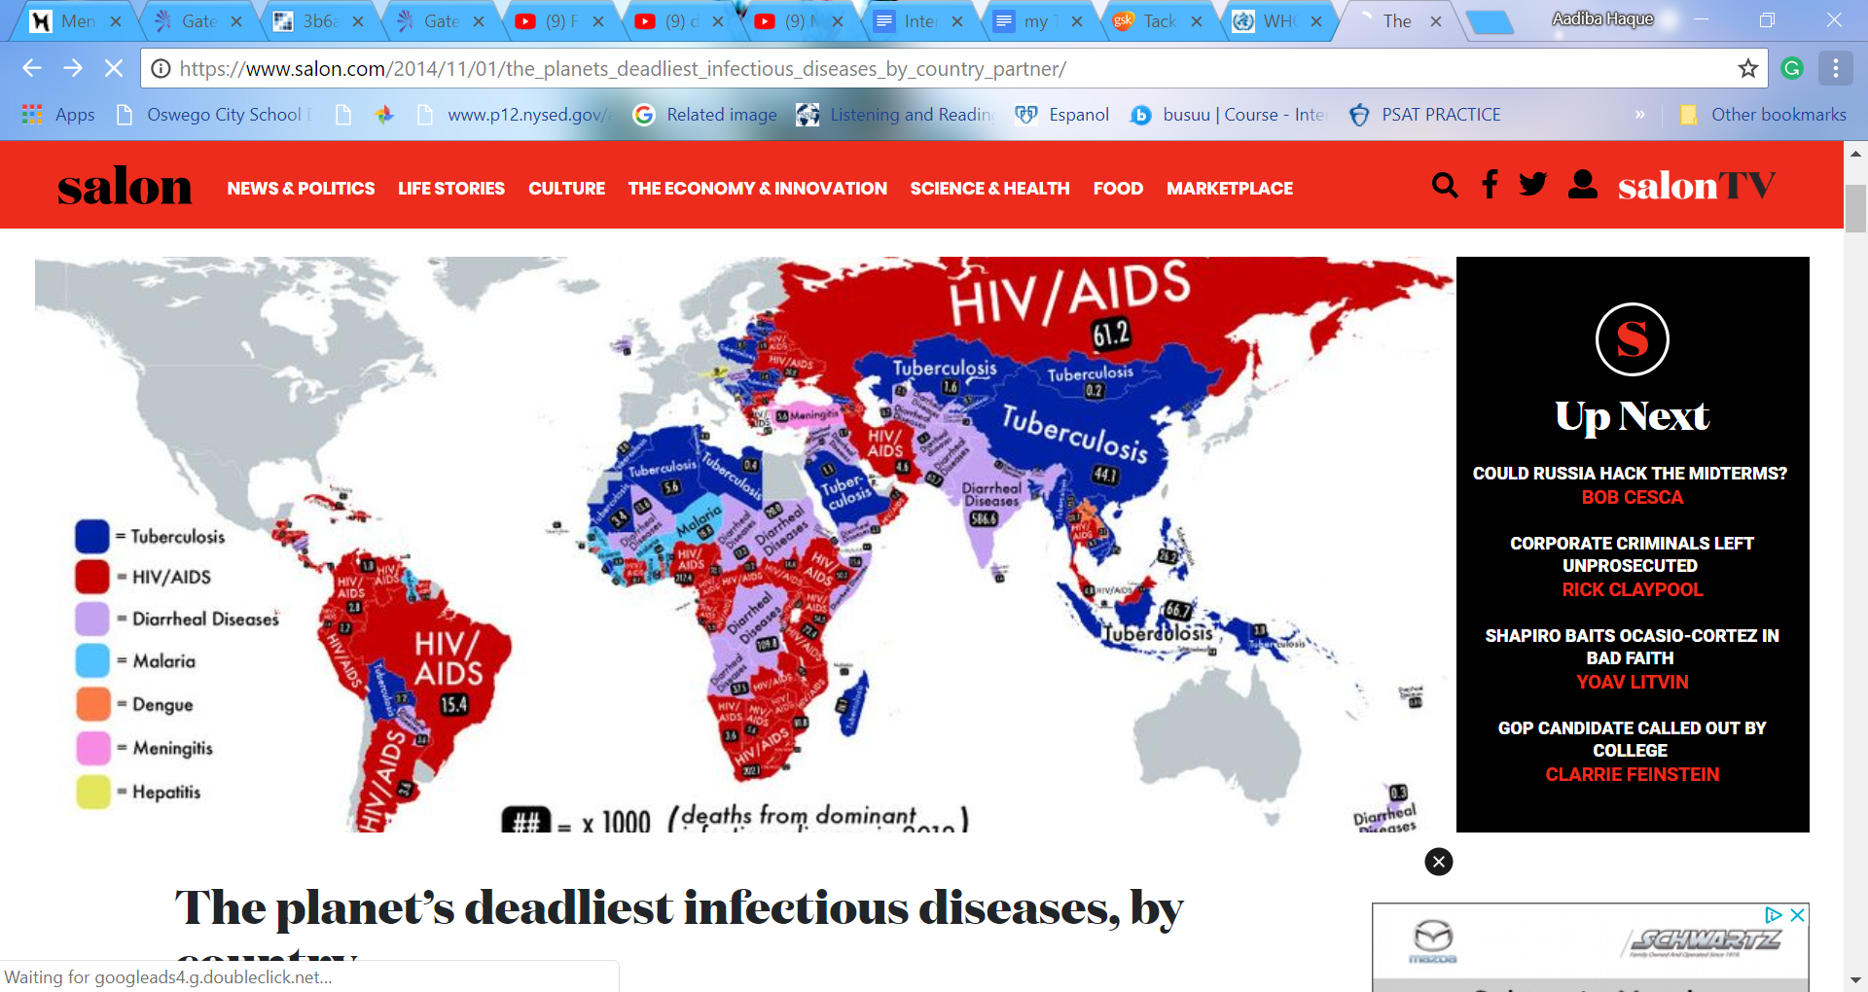

Diseases, epidemics, and other health problems stand as a concern in many developing countries, especially in Africa, Central and South America, and South Asia. Due to lack of education and resources, the health of millions of people in these countries is in danger. Bad hygiene, poor infrastructure(such as housing and irrigation systems), environmental factors such as pollution, and lack of doctors/medicines are all leading factors that cause epidemics to be such a huge issue in countries like Bangladesh and Sudan. For example, HIV/Aids is a big problem in many countries, and the lack of proper sex education may be a cause. In Bangladesh, diarrheal diseases are prevalent because the unsafe and contaminated water and lack of cleanliness of those who make food. Malaria causes more than 1.2 millions of deaths each year, the majority being young African children, and is caused by poorly designed irrigation and water systems, inadequate housing, poor waste disposal and water storage, and deforestation. Poor health is a major concern in third world countries, and is caused by many factors that root from poverty and improper education.

Links: <http://www.who.int/heli/risks/ehindevcoun/en/>

<https://www.gsk.com/en-gb/responsibility/health-for-all/tackling-diseases-in-developing-countries/#tab-6755>

How we can Help:

[https://water.org/our-impact/](https://water.org/our-impact/bangladesh/)

<https://thewaterproject.org/>

<http://www.isid.org/donate/>

<https://www.doctorswithoutborders.org/>

**Human Trafficking**

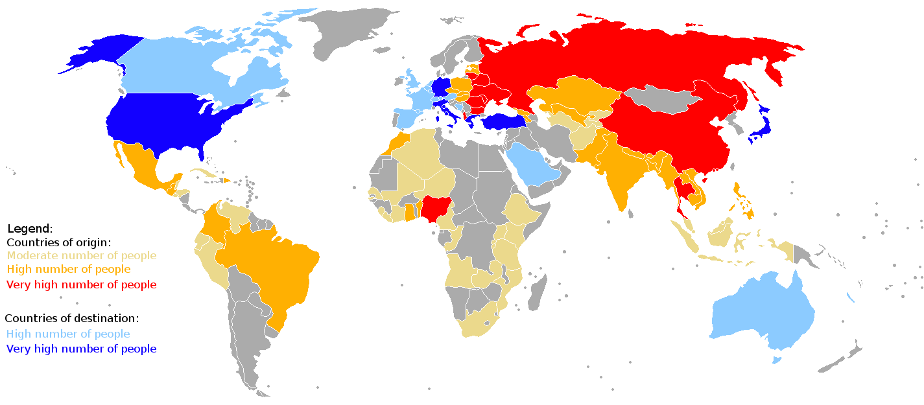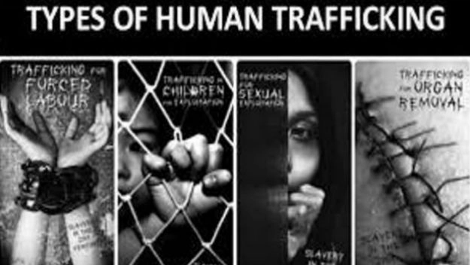

Human trafficking, also known as “Modern day slavery”, is the trade of humans to use for forced labor, sexual slavery, forced marriage, and for other illegal means. India, China, Russia, Venezuela, and other countries have a large amount of human trafficking cases. For the majority of the cases, labor exploitation is the result, but sexual exploitation, like forcing kidnapped girls to become prostitutes, is also a major result. Human traffickers usually target unattended children or women and kidnap them. However, many fall victim to this to escape poverty or for money. There are many campaigns against human trafficking---for example, the Blue Heart Campaign, which is international, and #LionHeart, which works to prevent the exploitation of kids in India.

***Need help?*** *United States:*

*1 (888) 373-7888*

### *National Human Trafficking Hotline*

***SMS:*** *233733 (Text "HELP" or "INFO")*

***Hours:*** *24 hours, 7 days a week*

***Languages:*** *English, Spanish and 200 more languages*

**Website:** [humantraffickinghotline.org](http://humantraffickinghotline.org/)

Links: <https://www.antislavery.org/slavery-today/human-trafficking/>

<https://variety.com/2016/film/news/lion-heart-campaign-india-1201924715/>

How you can help:

<http://lionheart.org/about/how-you-can-help/>

<https://www.themuse.com/advice/take-action-7-ways-to-join-the-fight-against-human-trafficking>

<https://www.unodc.org/blueheart/>

<https://www.cnn.com/2018/03/05/world/anti-trafficking-organizations-around-the-world/index.html>